DEPARTMENT OF CSE, CS&IT, AI&DS 2400033097 B.Vasavi
COURSE CODE: 24SDCS02 / 24SDCS02E / 24SDCS02P / 24SDCS02L
FULL STACK APPLICATION DEVELOPMENT
Date of the Session: / / Time of The Session: to
#SKILL - 3 Working with HQL - Sorting, Pagination & Aggregates
Prerequisites:
- Basic knowledge of Hibernate
- Basic idea of HQL syntax
In this lab, you will extend the Hibernate module created in Skill 2 and perform advanced data retrieval using HQL, including sorting, pagination, filtering, and aggregate functions. These operations help in retrieving structured and meaningful data from the database using Hibernate.
Tasks :
  - Use the Product entity created in Skill 2.
  - Add 5–8 additional Product records into the database.
  - Write HQL queries to retrieve all products sorted by price:
    - Ascending order
    - Descending order
  - Write an HQL query to sort products by quantity (highest first).
  - Implement pagination using HQL to display:
    - First 3 products
    - Next 3 products
  - Write HQL queries for aggregate operations:
    - Count total number of products
    - Count products where quantity > 0
    - Count products grouped by description
    - Find minimum and maximum price
  - Write an HQL query using GROUP BY to group products by description.
  - Write an HQL query using WHERE to filter products within a price range.
  - Write HQL queries using LIKE such as:
    - Names starting with certain letters
    - Names ending with certain letters
    - Names containing a pattern anywhere (substring)
    - Names with an exact character length
  - Push the Hibernate project to GitHub.

Project Structure:
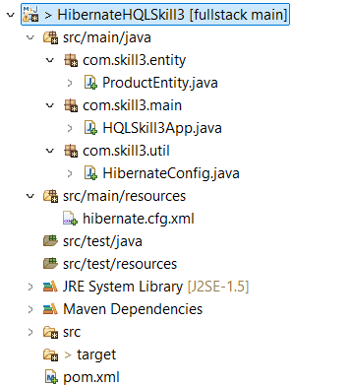

ProductEntity.java
package com.skill3.entity;
import javax.persistence.*;
@Entity
@Table(name = "product")
public class ProductEntity {
@Id
@GeneratedValue(strategy = GenerationType.IDENTITY)
private int productId;
private String productName;
private double price;
private int quantity;
private String description;
public ProductEntity() {}
public ProductEntity(String productName, double price, int quantity, String description) {
this.productName = productName;
this.price = price;
this.quantity = quantity;
this.description = description;
}
public int getProductId() { return productId; }
public String getProductName() { return productName; }
public double getPrice() { return price; }
public int getQuantity() { return quantity; }
public String getDescription() { return description; }
public void setProductId(int productId) { this.productId = productId; }
public void setProductName(String productName) { this.productName = productName; }
public void setPrice(double price) { this.price = price; }
public void setQuantity(int quantity) { this.quantity = quantity; }
public void setDescription(String description) { this.description = description; }
}

HQLSkillApp.java
package com.skill3.main;
import com.skill3.entity.ProductEntity;
import com.skill3.util.HibernateConfig;
import org.hibernate.Session;
import org.hibernate.Transaction;
import org.hibernate.query.Query;
import java.util.List;
public class HQLSkill3App {

public static void main(String[] args) {
Session session = HibernateConfig.getSessionFactory().openSession();
Transaction tx = session.beginTransaction();
session.save(new ProductEntity("Laptop", 55000, 10, "Electronics"));
session.save(new ProductEntity("Mobile", 25000, 15, "Electronics"));
session.save(new ProductEntity("Keyboard", 1200, 25, "Accessories"));
session.save(new ProductEntity("Monitor", 15000, 5, "Electronics"));
session.save(new ProductEntity("Tablet", 18000, 8, "Electronics"));
tx.commit();
Query<Object[]> q1 = session.createQuery(
"select p.description, count(p) from ProductEntity p group by p.description",
Object[].class
);
List<Object[]> groupList = q1.list();
for (Object[] o : groupList) {
System.out.println(o[0] + " : " + o[1]);
}
Query<ProductEntity> q2 = session.createQuery(
"from ProductEntity p where p.price between :min and :max",
ProductEntity.
);
q2.setParameter("min", 1000.0);
q2.setParameter("max", 30000.0);
q2.list(
session.createQuery(
"from ProductEntity p where p.productName like 'M%'",
ProductEntity.class
).list(
session.createQuery(
"from ProductEntity p where p.productName like '%e'",
ProductEntity.class
).list();
session.createQuery(
"from ProductEntity p where p.productName like '%top%'",
ProductEntity.class
).list();
session.createQuery(
"from ProductEntity p where length(p.productName) = 5",
ProductEntity.class
).list();
session.close();
HibernateConfig.getSessionFactory().close();
}
}

HibernateConfig.java
package com.skill3.util;
import org.hibernate.SessionFactory;
import org.hibernate.cfg.Configuration;
public class HibernateConfig {
private static SessionFactory factory;
static {
factory = new Configuration().configure().buildSessionFactory();
}
public static SessionFactory getSessionFactory() {
return factory;
}
}
Hibernate.cfg.xml
<?xml version="1.0" encoding="UTF-8"?>
<!DOCTYPE hibernate-configuration PUBLIC
"-//Hibernate/Hibernate Configuration DTD 3.0//EN"
"https://hibernate.sourceforge.net/hibernate-configuration-3.0.dtd">
<hibernate-configuration>
<session-factory>
<property name="hibernate.connection.driver_class">
com.mysql.cj.jdbc.Driver
</property>
<property name="hibernate.connection.url">
jdbc:mysql://localhost:3306/hibernate_db
</property>
<property name="hibernate.connection.username">root</property>
<property name="hibernate.connection.password">12345</property>
<property name="hibernate.dialect">
org.hibernate.dialect.MySQL8Dialect
</property>
<property name="hibernate.hbm2ddl.auto">update</property>
<property name="hibernate.show_sql">true</property>
<mapping class="com.skill3.entity.ProductEntity"/>
</session-factory>
</hibernate-configuration>

Pom.xml
<project xmlns="http://maven.apache.org/POM/4.0.0" xmlns:xsi="http://www.w3.org/2001/XMLSchema-instance" xsi:schemaLocation="http://maven.apache.org/POM/4.0.0 https://maven.apache.org/xsd/maven-4.0.0.xsd">
<modelVersion>4.0.0</modelVersion>
<groupId>com.skill3</groupId>
<artifactId>HibernateHQLSkill3</artifactId>
<version>0.0.1-SNAPSHOT</version>
<dependencies>
<dependency>
<groupId>org.hibernate</groupId>
<artifactId>hibernate-core</artifactId>
<version>5.6.15.Final</version>
</dependency>
<dependency>
<groupId>javax.persistence</groupId>
<artifactId>javax.persistence-api</artifactId>
<version>2.2</version>
</dependency>
<dependency>
<groupId>mysql</groupId>
<artifactId>mysql-connector-java</artifactId>
<version>8.0.33</version>
</dependency>
</dependencies>
</project>

Outputs:
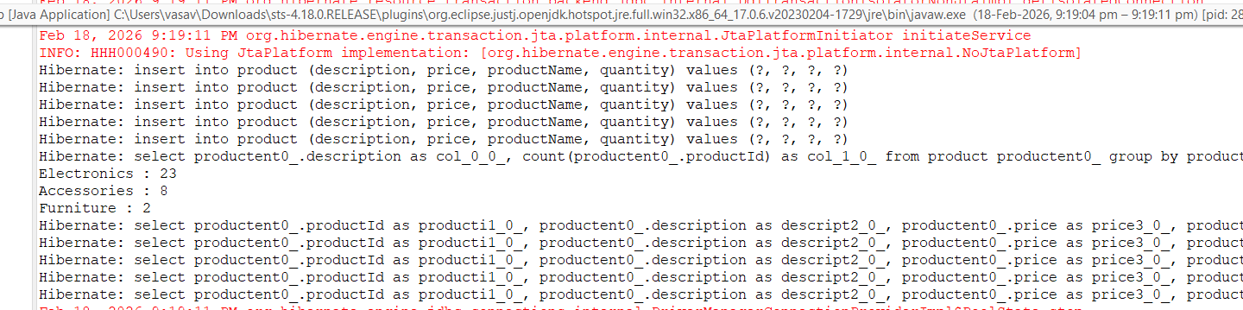

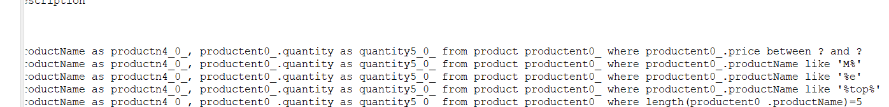

VIVA QUESTIONS:

- What is HQL and how does it differ from SQL?
- Why do we use sorting in HQL?
- What is pagination and where is it used?
- Name any three aggregate functions supported in HQL.
- What is the difference between HQL and HCQL (Hibernate Criteria Query Language)?
1ANS: HQL is Hibernate Query Language that works with Java objects, not tables.
Unlike SQL, it is database-independent and object-oriented.
2Ans:To arrange query results in ascending (ASC) or descending (DESC) order for easier viewing and reporting.
3Ans: Pagination splits results into smaller pages.
Used in web apps to display limited records per page and improve performance.
4Ans: count(), sum(), avg()
5Ans: HQL: String-based query for static queries.
HCQL (Criteria API): Object-oriented, dynamic queries built in Java.

(For Evaluator’s use only)

Comment of the Evaluator (if Any)

Evaluator’s Observation
Marks Secured: out of
EMP ID & Full Name of the Evaluator:

Signature of the Evaluator Date of Evaluation:

